Create a EC2 machine in AWS.

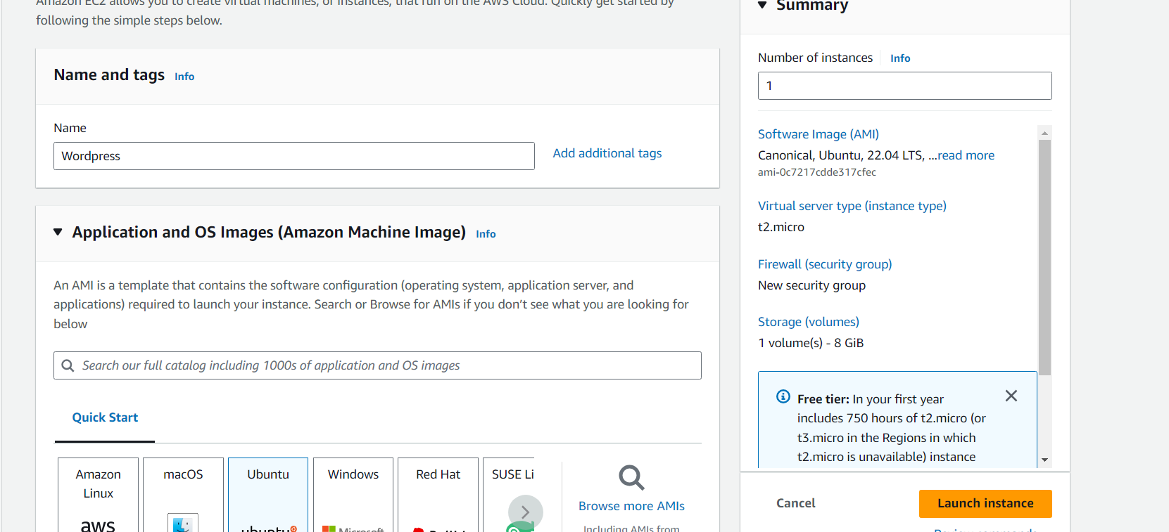

## Allow the Required Port to Access

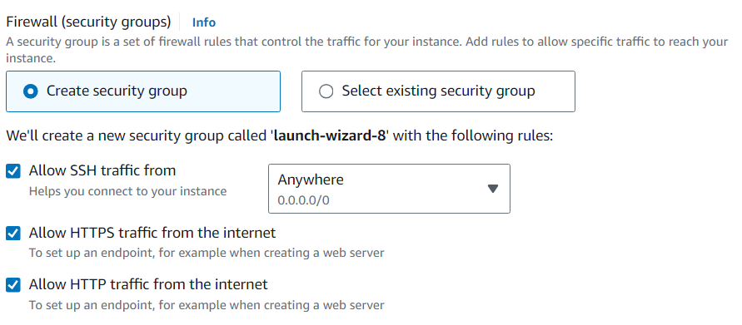

After install and configure all steps

